How to Build a Snake Game with JavaScript

April 29, 2022
- Topics:
- Languages
AddThis Sharing Buttons
Share to Facebook
Share to TwitterShare to LinkedIn

The best way to learn any programming language is through hands-on projects. The Snake Game is a simple game you can make using the basics of JavaScript and HTML.
The basic goal is to navigate a snake and eat as many apples as possible without touching the walls or the snake’s body.
In this article, we will go over step-by-step how to create this Snake Game using JavaScript and HTML.

Prerequisites
- Basic CSS knowledge.
- Basic JavaScript knowledge.
- Basic knowledge of HTML Canvas.

Table of contents
- Prerequisites
- Table of contents
- Display the canvas
- Display the snake
- Use arrow keys to change the snake’s direction
- Incorporate food
- Collision detection
- Increase length of the snake
- Incorporate score
- Implement game over logic
- Add game over text
- Conclusion

Display the canvas
First, we need to display the game board and the snake. Start by creating the file index.html. This will contain all of our code.
Next, open the file in your preferred browser. To be able to create our game, we have to make use of the HTML’s <canvas>, which is used to draw graphics with JavaScript.
Click here to learn more about HTML canvas.
Next, let’s create the canvas. We will use the <canvas> tag to create a canvas as follows:
<canvas id="game" width="400" height="400"/>
The id in the above template is used to identify our canvas
Until now the browser will not display anything since the canvas has no default background.
To make our canvas visible, we can give it a border by writing some CSS code. Add <style> and </style> tags after the </title> tag. Then key in the following block of code.
<style>
body{
margin: 0px;
padding: 0px;
display: flex;
flex-direction: column; /* arrage items on top of the other */
justify-content: center;
align-items: center;
}
canvas{
box-shadow: black 20px 10px 50px; /*elevate our canvas and add shadow*/

}
</style>
In the above code, we have added a box-shadow to our canvas. This will give us a nice border around our canvas. Now, we will create an index.js file that will contain our JavaScript code.
For the file to be effective on our HTML main file, we need to link the index.js file to the HTML file. This is done by adding the following line of code below the </canvas> tag.
<script src="index.js"></script>
Next step is to make the canvas where our snake will navigate. We will get the canvas element using the id game.
Then we get the canvas 2d context, which means that it will be drawn into a 2D space.
const canvas=document.getElementById('game'); const ctx=canvas.getContext('2d');
Next, add black background color to our canvas by creating a new function called clearScreen and calling it on our primary function drawGame.
function drawGame(){
clearScreen();

}

function clearScreen(){
ctx.fillStyle= 'black'// make screen black
ctx.fillRect(0,0,canvas.clientWidth,canvas.clientHeight)// black color start from 0px left, right to canvas width and canvas height
}
drawGame();
The fillStyle method is a kind of brush, which paints our screen with black color, and it is used together with the fillRect method, which paints the entire rectangle from coordinates (0,0) to the actual height and width of our canvas.
The following screen should appear:

The next task is to create the game loop that will update the screen; by creating a variable named speed that holds the number of times we will update the screen.
We also need a setTimeout() function which will calculate the interval between each update. This will be done in a function named drawGame().
function drawGame(){
let speed=7;//The interval will be seven times a second.

setTimeout(drawGame, 1000/speed);//update screen 7 times a second
}

Display the snake
In this section, we will first establish a variable called tileCount which will divide our screen into 20 small squares. Then define the horizontal position of our snake as headX, and initialize it with value 10.
We will also define the vertical position of our snake as headY, and initialize it with value 10 which will center our snake.
Next is to define the initial size of our snake, by creating a variable called tileSize and assigning it a value of 18.
To display our snake, we create a function named drawSnake, and then call it on our primary function drawGame as shown in the code snippet below.
let tileCount=20;
let tileSize=18;
let headX=10;
let headY=10;

function drawGame(){
clearScreen();
drawSnake();
}
function drawSnake(){
ctx.fillStyle="orange";
ctx.fillRect(headX* tileCount,headY* tileCount, tileSize,tileSize)

}
In the code snippet above, the orange paint color in the rectangle starts from coordinate (20,20) to our rectangle total height and width.
It displays the following result:
![snake]((/engineering-education/how-to-build-a-snake-game-with-javascript/orangesnake.PNG)

Use arrow keys to change the snake’s direction
We will set two variables named xvelocity and yvelocity, and initialize them with values zero.
//initialize the speed of snake
let xvelocity=0;
let yvelocity=0;
In order to enable the use of the arrow key for snake navigation, we create an event listener as shown below.
//add event listener to our body
document.body.addEventListener('keydown', keyDown);
Next, we will check if the pressed key matches one of the arrow keys. This will be done in a function called keyDown which will compare keys and their keycode.
function keyDown(event)

//up
{
if(event.keyCode==38){
yvelocity=-1; //move one tile up
xvelocity=0;

}
//down
if(event.keyCode==40){
yvelocity=1;//move one tile down
xvelocity=0;
}

//left
if(event.keyCode==37){
yvelocity=0;
xvelocity=-1;//move one tile left
}
//right
if(event.keyCode==39){
yvelocity=0;
xvelocity=1;//move one tile right
}
}
If the key pressed matches the given keycode we change the snake position in a function named changeSnakePosition().
function changeSnakePosition(){
headX=headX + xvelocity;
headY=headY+ yvelocity;

}

function drawGame(){
clearScreen();
drawSnake();
changeSnakePosition()
}
We also need to check if the snake is moving in the opposite direction of the new, intended direction.
This will prevent our snake from reversing, such as when you press the up arrow key when the snake is moving to the bottom.
function keyDown()
//up
{
if(event.keyCode==38){

if(yvelocity==1)
return; //prevent snake from moving in opposite direction
yvelocity=-1;
xvelocity=0;

}
//down
if(event.keyCode==40){
if(yvelocity==-1)
return;//prevent snake from moving in opposite direction
yvelocity=1;
xvelocity=0;
}

//left
if(event.keyCode==37){
if(xvelocity==1)
return;//prevent snake from moving in opposite direction
yvelocity=0;
xvelocity=-1;
}
//right
if(event.keyCode==48){
if(xvelocity==-1)
return;//prevent snake from moving in opposite direcction
yvelocity=0;
xvelocity=1;
}
}

Incorporate food
We will need to define the position of apple (food), both vertical and horizontal.
//draw apple
let appleX=5;
let appleY=5;
Then create a function named drawApple() which displays the apple.
function drawGame(){
clearScreen();
drawSnake();
changeSnakePosition()
drawApple()
}
function drawApple(){
ctx.fillStyle="red";// make apple red
ctx.fillRect(appleX*tileCount, appleY*tileCount, tileSize, tileSize)//position apple within tile count
}
The following should appear:
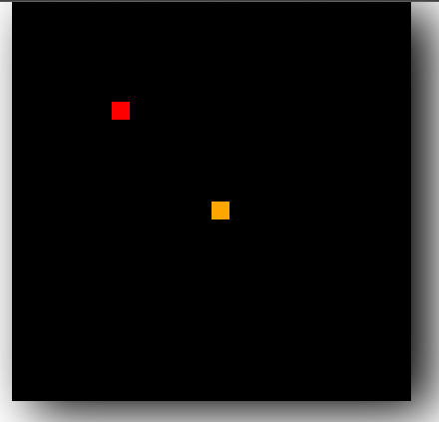

Collision detection
Let’s make the function checkCollision to generate an x-coordinate and a y-coordinate for the food’s positions.
We also have to ensure that the food is not located where the snake currently is. If it is, then we have to generate a new food location.
See the functions below:
function drawGame(){
clearScreen();
drawSnake();
changeSnakePosition()
checkCollision()
drawApple()
}
function checkCollision(){
if(appleX==headX && appleY==headY){
appleX=Math.floor(Math.random()*tileCount);
appleY=Math.floor(Math.random()*tileCount);
}
}

Increase length of the snake
We need to define an array named snakeParts which will hold the parts of the snake and a variable named tailLength which will keep track of the snake length.
This ensures the snake has the intended parts as described in the code snippet below.
// array for snake parts
const snakeParts=[];
let tailLength=2; //initial parts of snake

function checkCollision(){
if(appleX==headX && appleY==headY){ //collision happens when left, right ,top, and bottom sides of apple is in contact with any part of snake
appleX=Math.floor(Math.random()*tileCount); //generate apple to a random horizontal position
appleY=Math.floor(Math.random()*tileCount);//generate apple to a random vertical position
tailLength++;

}
Then we will track snake movement to ensure the added parts come after the tail.
class snakePart{
constructor(x, y){
this.x=x;
this.y=y;
}

}
Let us now draw the added parts of our snake. We will do it on the drawSnake function:
The added features will be green in color as shown below:
function drawSnake(){

ctx.fillStyle="green";
//loop through our snakeparts array
for(let i=0;i<snakeParts.length;i++){
//draw snake parts
let part=snakeParts[i]
ctx.fillRect(part.x *tileCount, part.y *tileCount, tileSize,tileSize)
}
snakeParts.push(new snakePart(headX,headY));//put item at the end of list next to the head
}

Incorporate score
We need to initialize a score variable to zero and increment it every time the snake eats the food.
To display the score, we will create a function named drawScrore which will set the font color to white, and position score text at the right-hand corner.
//scores
let score=0;

function drawGame(){
changeSnakePosition();
clearScreen();
drawSnake();
checkCollision()
drawApple();
drawScore();
setTimeout(drawGame, 1000/speed);//update screen 7 times a second
}
// score function
function drawScore(){
ctx.fillStyle="white"// set our text color to white
ctx.font="10px verdena"//set font size to 10px of font family verdena
ctx.fillText("Score: " +score, canvas.clientWidth-50,10);// position our score at right hand corner

}
Now let us increment the score value whenever there is a collision.
function checkCollision(){
if(appleX==headX && appleY==headY){ //if left, right, top, and bottom side of apple is in contact with any part of snake
appleX=Math.floor(Math.random()*tileCount); //move apple to a random horizontal position
appleY=Math.floor(Math.random()*tileCount);//move apple to a random vertical position

tailLength++; // increase tail length
score++; //increase our score value

}
}
These results should appear:
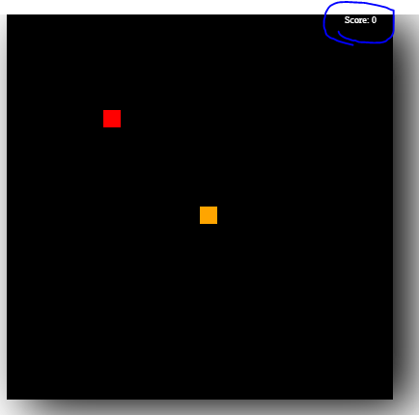

Implement game over logic
There are two cases in which the game can end. The head of the snake collides with its body and/or the head of the snake collides with the canvas boundary.
We will check these conditions in a function named isGameOver which returns true or false.
//Game Over function
function isGameOver(){
let gameOver=false;
//check whether game has started
if(yvelocity===0 && xvelocity===0){
return false;
}
if(headX<0){//if snake hits left wall
gameOver=true;
}
else if(headX===tileCount){//if snake hits right wall
gameOver=true;
}
else if(headY<0){//if snake hits wall at the top
gameOver=true;
}
else if(headY===tileCount){//if snake hits wall at the bottom
gameOver=true;
}

//stop the game when snake bumps into itself

for(let i=0; i<snakeParts.length;i++){
let part=snakeParts[i];
if(part.x===headX && part.y===headY){//check whether any part of snake is occupying the same space
gameOver=true;
break; // to break out of for loop
}

return gameOver;// this will stop the execution of the drawgame method
}
Now we will check if the value returned by isGameOver is true, if it is we stop further execution of the game.
// create game loop-to continously update screen
function drawGame(){
changeSnakePosition();
// game over logic
let result=isGameOver();
if(result){// if result is true stop other following function from exucuting
return;
}

clearScreen();
drawSnake();
checkCollision()
drawApple();

drawScore();
setTimeout(drawGame, 1000/speed);//update screen 7 times a second
}
Stopping execution results:
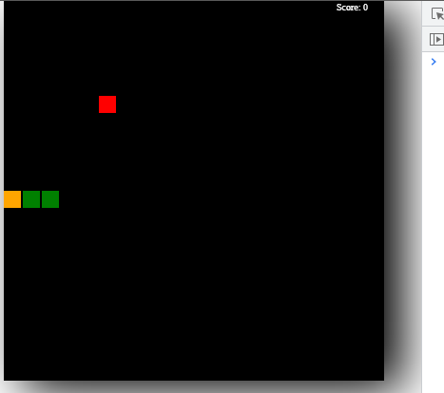

Add game over text
This text will appear whenever the game is over. We will implement this on a function named isGameOver.
function isGameOver(){
let gameOver=false;
//check whether game has started
if(yvelocity===0 && xvelocity===0){
return false;
}
if(headX<0){//if snake hits left wall
gameOver=true;
}
else if(headX===tileCount){//if snake hits right wall
gameOver=true;
}
else if(headY<0){//if snake hits wall at the top
gameOver=true;
}
else if(headY===tileCount){//if snake hits wall at the bottom
gameOver=true;
}

//stop the game when snake bumps into itself

for(let i=0; i<snakeParts.length;i++){
let part=snakeParts[i];
if(part.x===headX && part.y===headY){//check whether any part of snake is occupying the same space
gameOver=true;
break; // to break out of for loop
}
}
//display text Game Over
if(gameOver){
ctx.fillStyle="white";
ctx.font="50px verdana";
ctx.fillText("Game Over! ", canvas.clientWidth/6.5, canvas.clientHeight/2);//position our text in center
}

return gameOver;// this will stop the execution of the draw game method
}
Game over results:
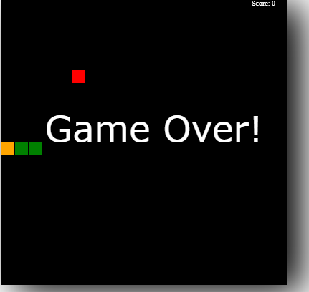
You can get the complete code here.

Conclusion
Fun projects are best to learn any programming language. In this project, we learned how to create a game using JavaScript.
We creates a snake game using the HTML’s canvas element and JavaScript methods to play the game depending on the set rules.
Happy coding!
https://www.section.io/engineering-education/how-to-build-a-snake-game-with-javascript/

